**Outline**

Develop an understanding of how images and graphics are drawn and stored in a computer. Learn about the RGB colour space. Apply Python concepts related to lists and loops.

**Objectives**

* tbd

**Materials**

* tbd

**Level 1: Pixels & RGB**

1. Create a new Repl for Python with Turtle.
   1. Copy and paste “Sample Program #1” from the listing at the end of this module.
   2. Run the program and examine the Turtle output
2. Colours can be specified by using a combination of three numbers. These three numbers together define a “Pixel” point in a graphic image.
   1. What position is the number that controls the amount of red (r) in the pixel?

The first number controls the amount of red in the pixel.

* 1. What position is the number that controls the amount of green (g) in the pixel?

The second number controls the amount of green in the pixel.

* 1. What position is the number that controls the amount of blue (b) in the pixel?

The third number controls the amount of blue in the pixel.

1. Colour number values can range from 0 to 255.
   1. What happens when the colour value is less than 255?

The colour would become a darker shade. If it is close to 255 it would be a bright shade. The lower the value goes the daker the shade becomes.

* 1. What happens when the colour value is close to 0?

If the value is close to zero then the shade will be very dark. If it is 0 or very close like 1 or 2 it will basically be black.

1. Other shades of colours can be created using a combination of r,g,b number values.
   1. Create a pixel containing a shade of the colour orange.

(255,80,0)

* 1. Create a pixel containing a shade of the colour yellow.

(255,255,0)

* 1. Create a pixel containing a shade of your favorite colour.

Royal blue -- (0,25,150)

1. Black, white, and shades of grey are created using combinations of equal r,g,b number values.
   1. Create a completely white pixel.

(255,255,255)

* 1. Create a completely black pixel.

(0,0,0)

* 1. Create a pixel containing a shade of middle grey.

(170,170,170)

**Level 2: Images Using Pixels**

1. Download the image “Resoultion_284x177.jpg” from Topic B folder in the class repository.
   1. Open the image in a program like Paint or Photoshop.
   2. What is the size of this image? How many pixels does it contain?

The image is 3.944 inches wide and the height is 2.458 inches. It contains284 pixels across and 177 pixels at its height.

* 1. Describe how the image looks (e.g. Can you see the pixels?)

The image looks pretty smooth in the size it is in right now. Some pixels can be seen at the edge is the shapes however one needs to look carefully in order to spot them.

* 1. Zoom in the view to enlarge the image
  2. Describe how the image looks (e.g. Can you see the pixels?)

When the image is enlarged there are many pixels that can be seen clearly, especially the ones of the edge of the bird and flower in the picture.

1. Download the image “Resoultion_16x16.jpg” from Topic B folder in the class repository.
   1. Open the image in a program like Paint or Photoshop.
   2. What is the size of this image? How many pixels does it contain?

The width and the height of the image is 0.111 inches. There are 8 pixels for both the width and height.

* 1. Describe how the image looks (e.g. Can you see the pixels?)

The size of the image right now makes the image barely visible. Main colours could be made out (light green, dark green and yellow).

* 1. Zoom in the view to enlarge the image
  2. Describe how the image looks (e.g. Can you see the pixels?)

The pixels of the image are very clearly visible and it is a little difficult to make out what the actual image is.

1. Create a new Repl for Python with Turtle.
2. Copy and paste “Sample Program #2” from the listing at the end of this module.
3. Run the program and examine the Turtle output
4. Compare the program output to the “Resoultion_16x16.jpg” image in question #2 above.

The image is very similar from the one is question #2 however the pixels in repl are round where as in the image they were squares.

1. Explain how the program code in lines 52 to 58 works. (i.e. The main program code.)
2. How the program prints out pixels to produce and 8 by 8 resolution image.

Code lines 52 instructs to contain 8 pixels in each row. Code line 53 and 54 also says to have 8 pixels in both rows and columns. This is what makes the image come out as 8 by 8.

1. How the program decides which colour information to use for each pixel.

The instructions above 52 (12-24) decide the colour of the fill, this is put under the variable “pixelMemory”. The main program just tells python to remember the pixel memory and create the pixels, putting the above coding into action.

1. Explain the purpose of the code in lines 12 to 21
2. How this code is related to the pixels produced by the main program.

This code determines the colour of filling the pixels will have. This coding is under a variable “pixel Memory”. When this variable is correctly put into the main program, the circles became the colours they were instructed to be in the coding lines 12 through 24.

1. The RGB value of the 19th pixel in the image

(28,28,12)

1. The RGB value of the pixel in the 5th column on the 4th row.

(154,140,22)

1. Modify the main program to print the image upside-down (i.e. pixels in reverse order).
2. Show your modified image to Mr. Nestor.
3. Explain your changes to the program code below.

I created a new line for 53 and added pixelAdress=63.I also changes my pixelAdress in code line 57 to a -1 instead of a positive 1.

1. Modify the main program to print the image at a resolution of 12 by 4 pixels.
2. Show your modified image to Mr. Nestor.
3. Explain your changes to the program code below.

I changed my row range to 12 in code line 54 and my column range to 4 in code line 55.

**Level 3: Your Custom Image**

1. Use and modify the sample pixel program code to create your own custom image.
   1. Create a larger resolution image than provided in the sample.
   2. Make sure the image is recognizable (or a clear pattern).
   3. Show your image to Mr. Nestor.
2. List and explain your modified image code below.

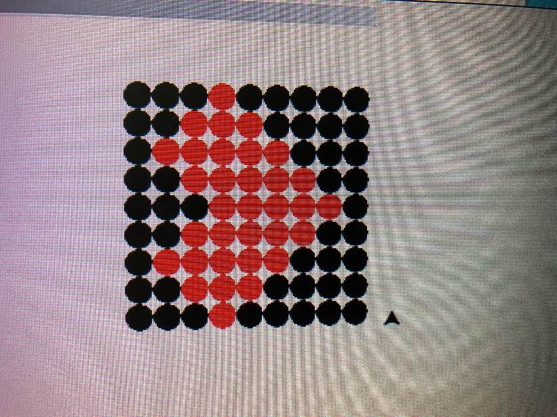

I modified the number of pixels from 64 to 81. Pixels 12, 16, 20-22, 24-26, 28-36, 38-44, 48-52, 58-60, 68 are all filled in with the colour red (255,0,0) which make up a heart. The others are filled with black (0,0,0). The range of the row and column was also changed from 8 by 8 to 9 by 9.

import turtle

myPen = turtle.Turtle()

# These variables track the position of the turtle pen

posX = 0

posY = 0

# These variables define the image information.

# Each pixel in the image has a (r,g,b) value

# The complete image is simply a list of pixels

pixelAddress = 0

pixelMemory = [

(0,0,0),(0,0,0),(0,0,0),(0,0,0),(0,0,0),(0,0,0),(0,0,0),(0,0,0),(0,0,0),

(0,0,0),(0,0,0),(255,0,0),(0,0,0),(0,0,0),(0,0,0),(255,0,0),(0,0,0),(0,0,0),

(0,0,0),(255,0,0),(255,0,0),(255,0,0),(0,0,0),(255,0,0),(255,0,0),(255,0,0),(0,0,0),

(255,0,0),(255,0,0),(255,0,0),(255,0,0),(255,0,0),(255,0,0),(255,0,0),(255,0,0),(255,0,0),

(0,0,0),(255,0,0),(255,0,0),(255,0,0),(255,0,0),(255,0,0),(255,0,0),(255,0,0),(0,0,0),

(0,0,0),(0,0,0),(255,0,0),(255,0,0),(255,0,0),(255,0,0),(255,0,0),(0,0,0),(0,0,0),

(0,0,0),(0,0,0),(0,0,0),(255,0,0),(255,0,0),(255,0,0),(0,0,0),(0,0,0),(0,0,0),

(0,0,0),(0,0,0),(0,0,0),(0,0,0),(255,0,0),(0,0,0),(0,0,0),(0,0,0),(0,0,0),

(0,0,0),(0,0,0),(0,0,0),(0,0,0),(0,0,0),(0,0,0),(0,0,0),(0,0,0),(0,0,0)

]

# This user defined function draws a single image pixel

def drawPixel(rgb) :

global posX

myPen.down()

myPen.color(rgb)

myPen.begin_fill()

myPen.circle(8)

myPen.end_fill()

myPen.up()

myPen.forward(18)

posX = posX + 18

# This user defined function starts a new row of pixels

def newRow() :

global posX

global posY

myPen.up()

myPen.left(180)

myPen.forward(posX)

myPen.left(90)

myPen.forward(18)

myPen.left(90)

myPen.down()

posX = 0

posY = posY + 18

# THE MAIN PROGRAM CODE STARTS HERE

#

# Draw eight rows of the image.

# Each row contains eight pixels

for row in range (9) :

for column in range(9) :

drawPixel(pixelMemory[pixelAddress])

pixelAddress += 1

newRow()

**SAMPLE PROGRAM #1**

import turtle

myPen = turtle.Turtle()

# These variables track the position of the turtle pen

posX = 0

posY = 0

# This user defined function draws a single image pixel

def drawPixel(rgb) :

global posX

myPen.down()

myPen.color(rgb)

myPen.begin_fill()

myPen.circle(8)

myPen.end_fill()

myPen.up()

myPen.forward(18)

posX = posX + 18

# THE MAIN PROGRAM CODE STARTS HERE

#

redColor = (255,0,0)

drawPixel(redColor)

drawPixel((128,0,0))

greenColor = (0,255,0)

drawPixel(greenColor)

drawPixel((0,128,0))

blueColor = (0,0,266)

drawPixel(blueColor)

drawPixel((0,0,128))

**SAMPLE PROGRAM #2**

import turtle

myPen = turtle.Turtle()

# These variables track the position of the turtle pen

posX = 0

posY = 0

# These variables define the image information.

# Each pixel in the image has a (r,g,b) value

# The complete image is simply a list of pixels

pixelAddress = 0

pixelMemory = [

(15,15,5),(13,13,6),(8,10,3),(23,21,10),(32,33,16),(33,52,22),(32,54,21),(25,42,17),

(21,19,17),(20,18,9),(7,7,6),(58,65,11),(42,47,7),(11,8,6),(24,25,8),(21,28,10),

(25,19,5),(16,13,8),(28,28,12),(191,192,18),(205,202,21),(42,42,14),(11,11,4),(16,11,3),

(34,59,10),(35,47,15),(24,35,12),(156,139,26),(154,140,22),(28,43,10),(9,12,1),(19,22,5),

(42,88,15),(48,94,18),(98,120,49),(213,195,123),(109,134,66),(44,91,15),(52,86,22),(43,85,18),

(50,95,13),(63,104,39),(224,213,156),(255,225,140),(120,153,92),(41,99,17),(58,103,28),(42,98,17),

(35,86,13),(71,105,42),(223,208,144),(216,204,146),(100,134,82),(28,87,3),(39,83,12),(32,80,12),

(49,102,29),(57,109,33),(92,125,53),(66,103,36),(29,66,13),(32,76,17),(48,91,26),(47,93,23)

]

# This user defined function draws a single image pixel

def drawPixel(rgb) :

global posX

myPen.down()

myPen.color(rgb)

myPen.begin_fill()

myPen.circle(8)

myPen.end_fill()

myPen.up()

myPen.forward(18)

posX = posX + 18

# This user defined function starts a new row of pixels

def newRow() :

global posX

global posY

myPen.up()

myPen.left(180)

myPen.forward(posX)

myPen.left(90)

myPen.forward(18)

myPen.left(90)

myPen.down()

posX = 0

posY = posY + 18

# THE MAIN PROGRAM CODE STARTS HERE

#

# Draw eight rows of the image.

# Each row contains eight pixels

for row in range (8) :

for column in range(8) :

drawPixel(pixelMemory[pixelAddress])

pixelAddress += 1

newRow()